**Telephone Connection system**

***Introduction :***

A telephone connection system is a system that helps us to hold and search records of telephone connections of customers .It is like a telephone directory that helps us to find records in minimum time.

**CERTIFICATE OF COMPLETITION**

This is certified that **SHAIKH HAMZA  ISMAIi** and **ABUDUJANA NOOH  BUTT,**submitted Project entitled “Telephone Connection System” as i-Project of ACCP.

IPRO-201605B

**INTRODUCTION**

***ABOUT THE COMPANY***

***EQUINOR*** is a telecommunication company that has mobile connections as well as landline connections for its customers.The promising service we provide is our key to success.We never compromise on quality.

***PROBLEN STATEMENTS***

***Standards plan:-***

1. Every code block must have comments.

1. The logic of the program needs to be explained. Proper documentation should be maintained.

1. Complete Project Report along with synopsis, code and documentation should be prepared.

***Note:-***

Don’t forget to take your data backup every day. This will save your project work from the following:

a. Virus problem

b. System failure

c. File corrupt

Data Backup is an important event to be done on regular basis in a project management.

**REQUIREMENT SPECIFICATION**

1. The system will support registering new user connections.
2. Every user registered should have unique telephone (contact) number been assigned.
3. Following information should be stored for each user:
   1. Name
   2. Telephone Number
   3. Address
   4. City
   5. Mode of Connection (Mobile/Landline etc.)
   6. Type of Connection (Prepaid/Postpaid)
4. Users of this system can search for telephone numbers by name, city etc.
5. Users of this system can search for user details by providing number.
6. System should provide report based on Mode of Connection.
7. System should provide report based on Type of Connection.
8. Perform necessary validations.

**HARDWARE AND SOFTWARE REQIREMENTS**

***Hardware:-***

1. A minimum computer system that will help you access all the tools in the courses is a Pentium 166 or better.
2. 64 Megabytes of RAM or better.
3. Windows 98 (or higher if possible)

Java Virtual Machine.

***Software:-***

* Notepad/Textpad/Java editor
* j2sdk1.4.1_02 (or later) / .Net / J2EE
* JSP / Servlets
* EJB / Struts
* JDBC
* SQL Server 2000 (or later) / Oracle 9i / MS Access
* JDBC Driver

**TASK SHEET**

|  |  |  |  |  |
| --- | --- | --- | --- | --- |
| **S.NO.** | **TASK** | **TASK DURATION** | **GROUP MEMBER NAME** | **STATUS** |
| **1** | **Analysis** | **01 Days** | **ABUDUJANA NOOH  BUTT,**  **SHAIKH HAMZA  ISMAIL** | **Done** |
| **2** | **Design** | **05 Days** | **ABUDUJANA NOOH  BUTT,**  **SHAIKH HAMZA  ISMAIL** | **Done** |
| **3** | **Re-Design** | **02 Days** | **ABUDUJANA NOOH  BUTT,**  **SHAIKH HAMZA  ISMAIL** | **Done** |
| **4** | **Development** | **12 Days** | **SHAIKH HAMZA  ISMAIL** | **Done** |
| **5** | **Testing** | **half Days** | **ABUDUJANA NOOH  BUTT,**  **SHAIKH HAMZA  ISMAIL** | **Done** |
| **6** | **Documentation** | **Some Hours** | **ABUDUJANA**  **NOOH  BUTT** | **Done** |

**Login Form**

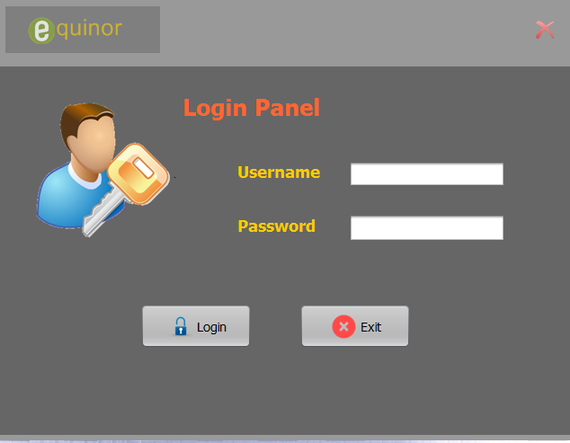

User can login through this panel

**Main Frame**

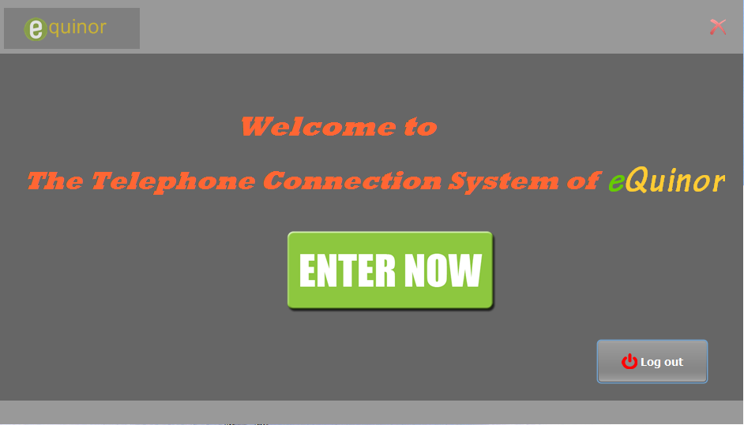

This is the mainframe

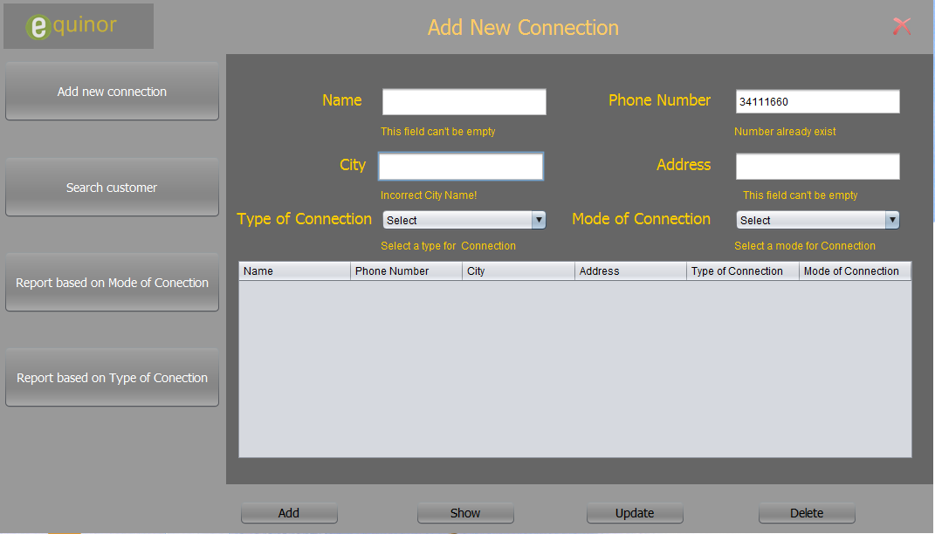

**Register Form**

User can add new connections through it

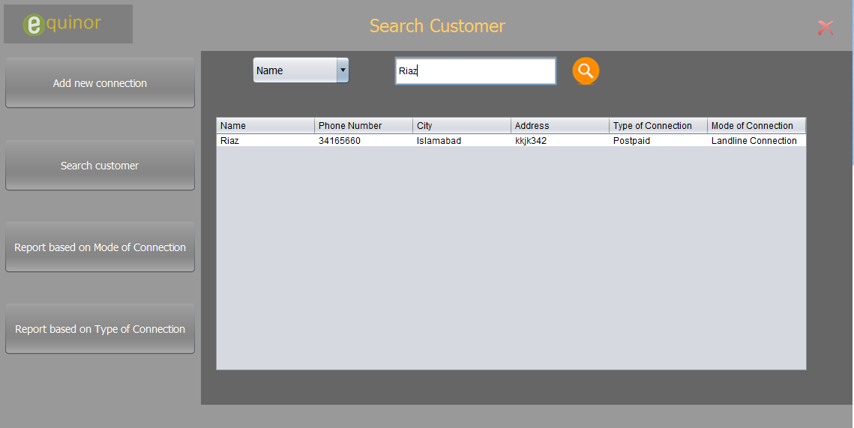

**Search Customer**

User can search customer through it

**Report based on mode of connection**

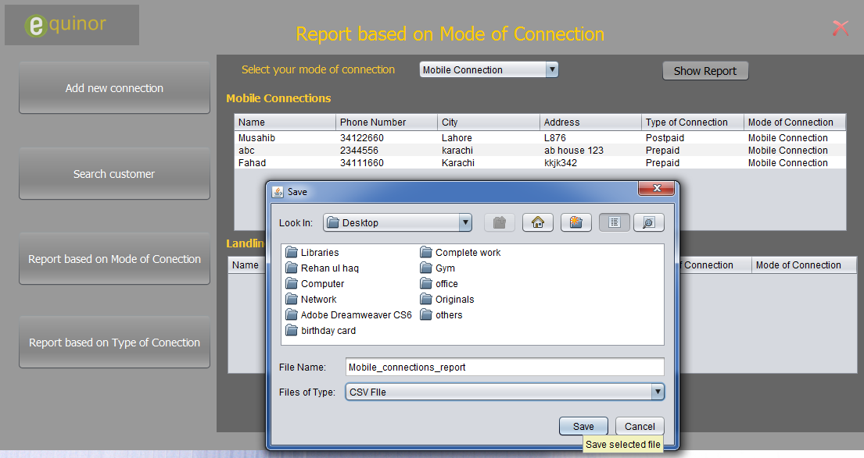

User can create report based on mode of connection

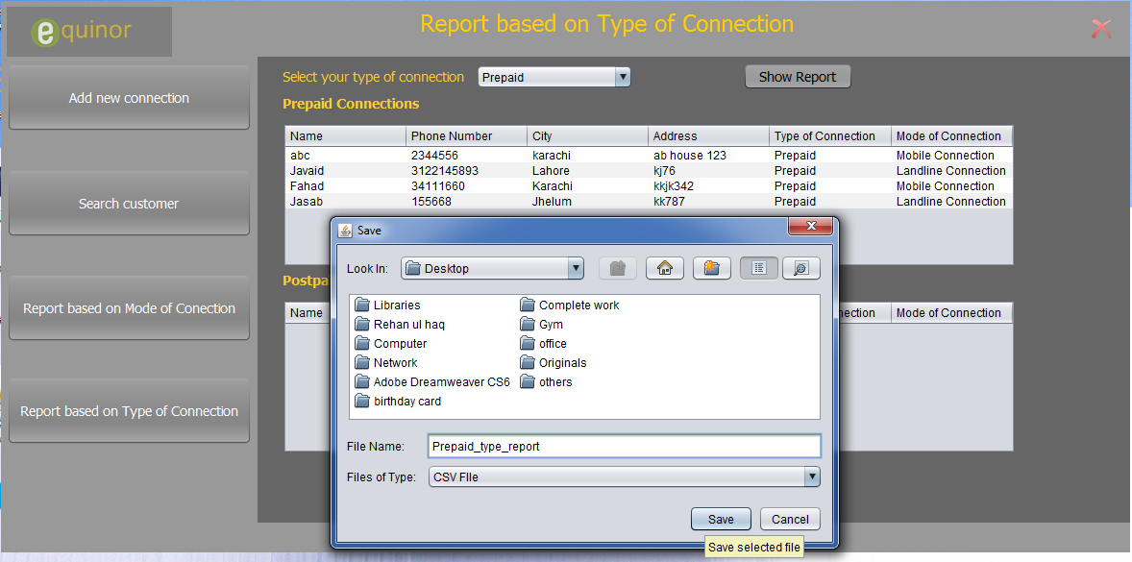

User can create report based on type of connection

**Report based on type of connection**